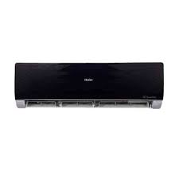

Haier HSU

* Cooling Type Heat & Cool
* Technology Inverter
* Cooling Capacity 1.0 Ton
* Wall Mounted Split
* Rs.67,499